M05 Tutorial - Django Deploy and Views

Link to GitHub project - <https://github.com/bidhyagtm/myblog>

Screenshots

* Deploy

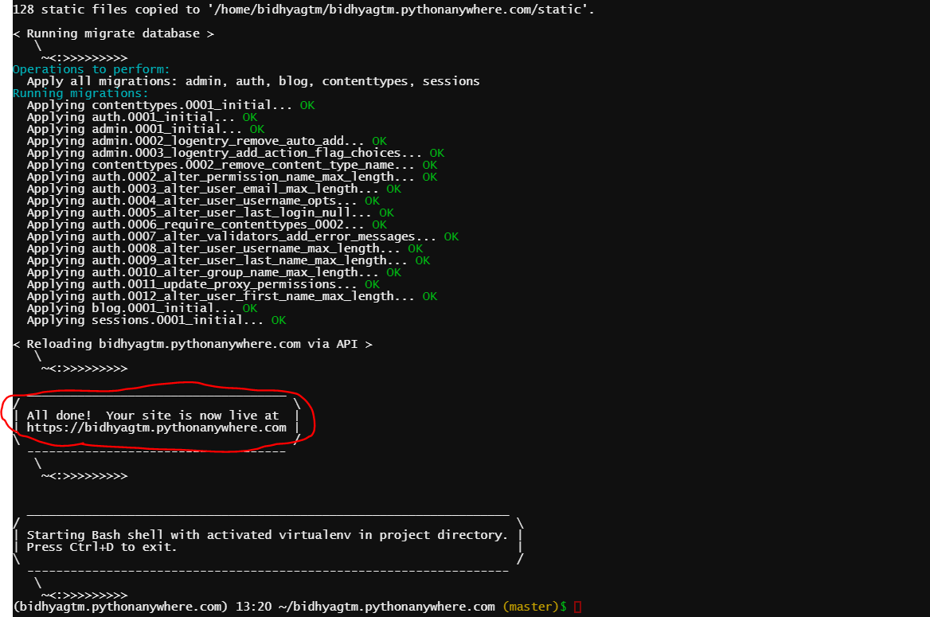

* Django URLS

* Django Views - time to create!

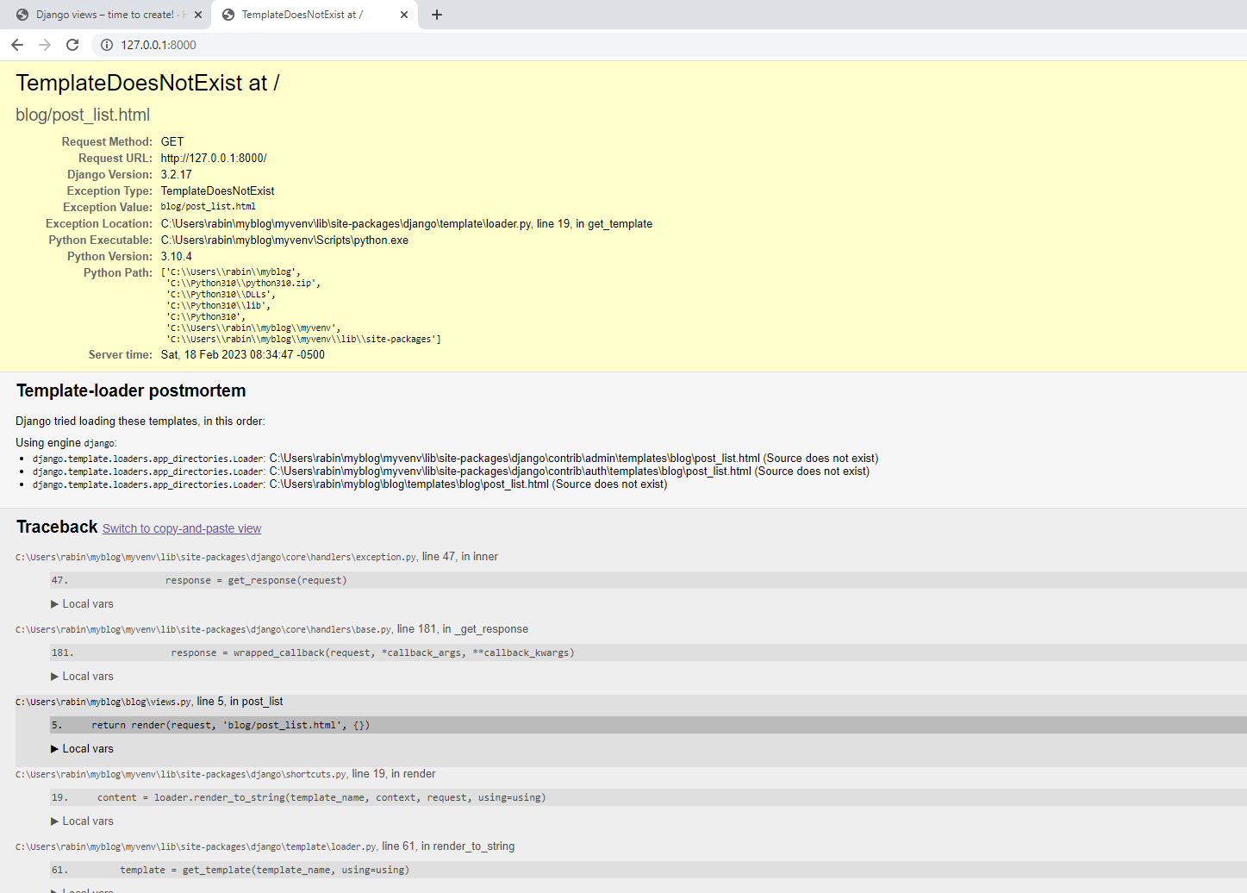

* Introduction to HTML

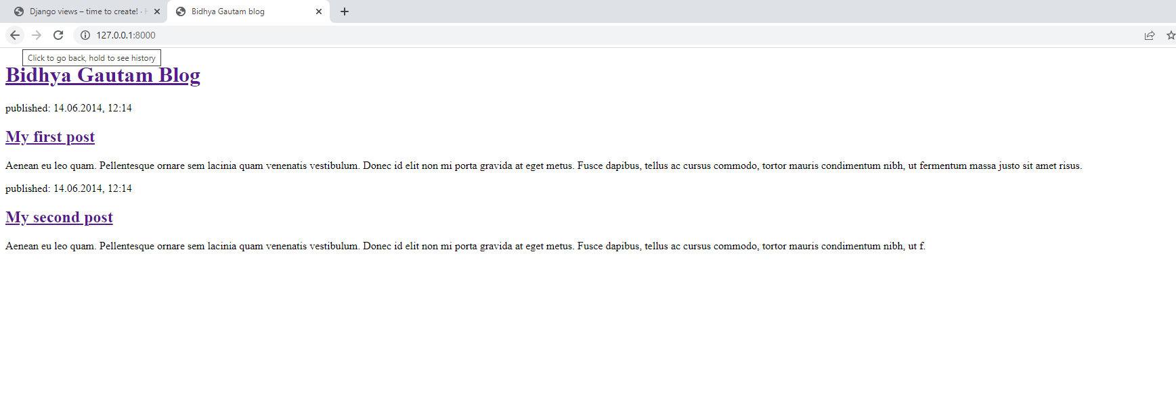

* Django ORM

